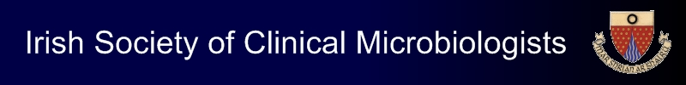

ISCM Spring Meeting

Friday 29th March 2019

Radisson Hotel, Golden Lane, Dublin 8

Abstract Submission Form

- Please e-mail completed abstract forms to Lisa McDowell at info@iscm.ie by 4pm on Monday 25th February 2019
- Please confirm that all authors have reviewed the abstract and agree its contents:…………………………………………………………………………………

Presenting author:

Institution:

Telephone number:

E-mail address:

Authors:

Abstract title:

Abstract text (maximum 300 words):

