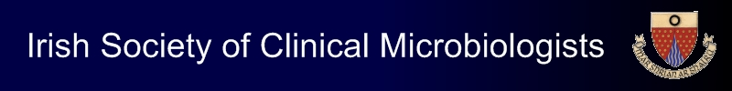

ISCM Autumn Meeting

Friday 16th October 2020

Venue: Online via Zoom

Abstract Submission Form

- Please e-mail completed abstract forms to Lisa McDowell at info@iscm.ie by 4pm on Monday 28th September 2020
- Please confirm that all authors have reviewed the abstract and agree its contents:…………………………………………………………………………………

Presenting author:

Institution:

Telephone number:
E-mail address

Authors:

Abstract title:

Abstract text (maximum 300 words):

