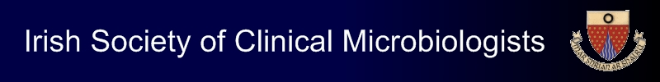

ISCM Spring Meeting

Friday 31st March 2023

Royal Marine Hotel, Dun Laoghaire, Dublin

Abstract Submission Form

- Please e-mail completed abstract forms to Lisa McDowell at info@iscm.ie by 4 pm on Friday 3rd March 2023.
- Abstract texts are limited to a maximum of 300 words.
- Please confirm that all authors have reviewed the abstract and agree its contents:………………………………………………………………………………

Presenting author:

Institution:

E-mail address:

Authors:

Title:

Abstract texts:

